Author
Institutional Affiliation
Instructor
Course code
Date of submission

The study of human behavior would not be complete without classical conditioning, which explained the relationship between the response and stimuli. Classical conditioning refers to learning that uses association and is developed by one of the prominent psychologists, Ivan Pavlov. He observed that when two stimuli are joined together, they produce a new response, which is the learned response from this association. In proving this theory, he uses the experiment with a dog, and the responses were observed and used to explain human beings' behavior. He used Pavlov's dog to observe how learning took place through association (McLeod, 2007). Just like other discoveries, this one was also done accidentally as he attended to his pet.
In his observations with his dogs, there is a relationship between the dog's salivating and the presentation of food and ringing of a bell. The dog would salivate when food is presented with food always after a bell rang. He would ring the bell and then present the food to the dog. The dog would salivate when food was presented to it, and this continued for some time until Pavlov changed the pattern. He rang the bell, but he did not present the food. Food was the original stimuli whose response from the dog was salivation. He replaced the stimuli with the ringing of the bell, and the dog would still salivate. This shows the learning of a new response through the association of stimuli. This is one of the historical developments of psychology because human behaviors would be attributed to the association of learning.
According to Akpan, (2020) this theory has been used by psychologists to intervene when one shows undesirable behaviors such as addiction. Psychiatrists rely on this principle to replace the stimulus to bad behaviors and associate it with something desirable to reflect on the beneficial new values. Classical conditioning marked a new era in understanding human beings' behavior and how associative learning can be used to instill good character in learners and children at home. The studies of Pavlov was famous in 1890-1930. The two stimuli must be presented close together, such as food and the bell, to be effective for associative learning. Pavlov theory has been used in learning institutions in teaching learners with difficulties and special needs by associating what they love with learning to achieve the intended goal of learning.

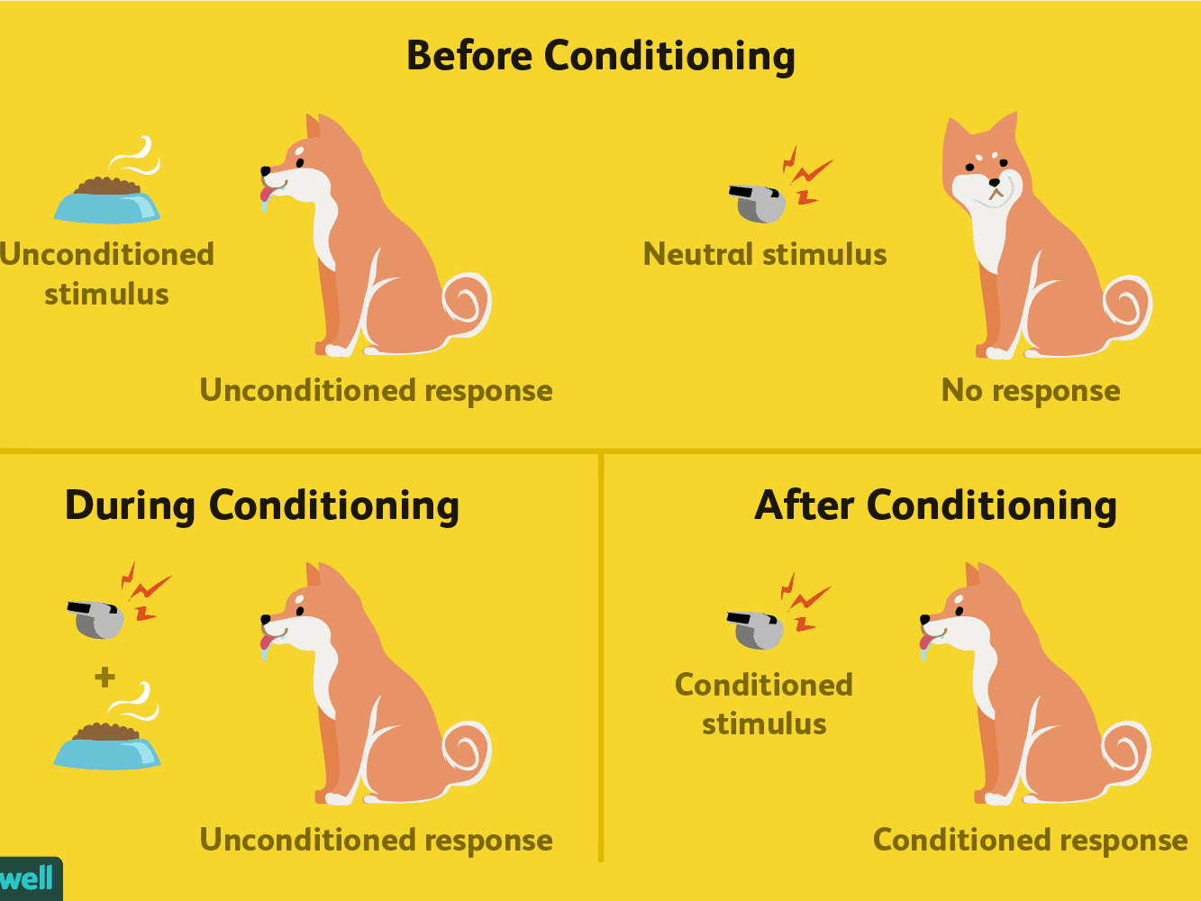

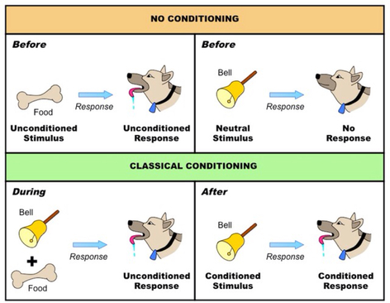

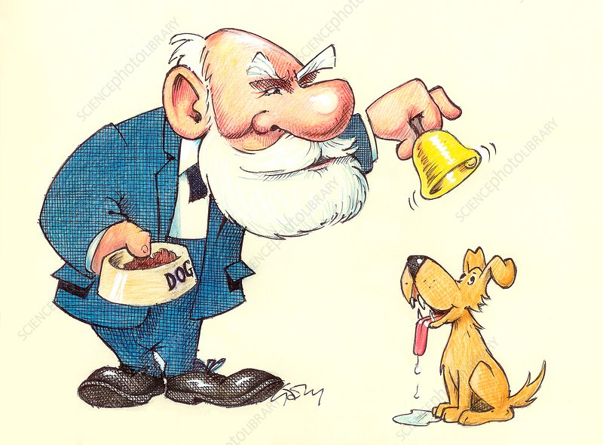

REFERENCES.
McLeod, S. A. (2007). Pavlov's dogs. Simply Psychology.
Akpan, B. (2020). Classical and Operant Conditioning—Ivan Pavlov; Burrhus Skinner. In Science Education in Theory and Practice (pp. 71-84). Springer, Cham.

